5th February 2025

Dear Parent/Carers,

**The launch of the Magical Reading Vending Machine!**

Hopefully you may have heard about our exciting new Vending Machine which will be full of fabulous books. The children have been creating a design for the machine based on the slogan ‘Something Very Magical Can Happen When You Read A Good Book’ and the winning designs have gone away to be ‘wrapped’ around the vending machine.

Any child reading at home, on 4 or more occasions, will be given a reading ticket each week and then at the end of each half term, tickets will be drawn by Mrs McAughey. The winning tickets for each phase through school will exchange their ticket for a token to spend in the Magical Vending Machine and choose a book of their own to take home and enjoy.

Please record reading at home in Home School Diaries and bring into school each day. Reading at home can be anything your child enjoys (including sharing a picture book) alongside their school book: books, magazines, newspapers etc.

We will be starting the magical tokens after February half-term.

We look forward to showing off our Vending Machine and announcing our first winners.

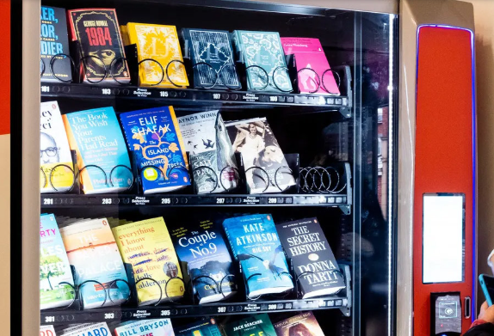Mrs McAughey.